

**Mine water: a sustainable renewable energy resource?**

Confirmation report

Fiona Todd

School of GeoSciences

April 2018

Supervised by: Dr. Chris McDermott, Dr. Andrew Fraser Harris, Dr. Stuart Gilfillan (University of Edinburgh) and Dr. Alex Bond (Quintessa Ltd)

**Confirmation report**

Table of Contents

1 Context 1

1.1 Background 1

1.2 Utilising abandoned mines as a heat source and store 1

1.3 System set-up 3

1.4 Mining methods 3

2 Research area 4

3 Research method 5

3.1 Aim 5

3.2 Research questions 5

3.3 Modelling code 6

3.4 Case study site 7

4 Conceptual model 8

4.1 Overview 8

4.2 Hydrogeological processes 8

4.3 Heat flow 10

4.4 Assumptions 12

5 Preliminary results 13

5.1 Overview 13

5.2 Model set up 13

5.3 Initial results 16

5.4 Model development 19

6 Plan 20

7 Resources 22

7.1 Budget 22

7.2 Data management plan 22

7.3 Training 23

8 Supervisory arrangements 23

9 Collaborations 24

10 References 1

Table of Appendices

Appendix A: Initial model results

Table of Figures

Figure 3.1: Excerpt from 2017 relative land motion map 7

Figure 4.1: Hydrogeological conceptual model for generic mine workings 9

Figure 4.2: Pillar and stall workings detail, adapted from Adams and Younger (2001) 9

Figure 4.3: Conceptualisation of heat flow mechanisms 11

Figure 5.1: Numerical model set up 14

Figure 5.2: Stall permeability sensitivity analysis 17

Figure 5.3: Abstraction rate sensitivity analysis 17

Figure 5.4: Pressure boundary sensitivity analysis 18

Figure 5.5: Comparison of sensitivity analyses 19

Figure 6.1: Detailed 6 month plan 20

Figure 6.2: Outline PhD plan 21

Figure 9.1: Potential collaborators 24

Table of Tables

Table 5.1: Model fluid parameters 15

Table 5.2: Model material properties 16

Table 6.1: Relevant conferences 21

Table 7.1: Budget 22

Table 7.2: Data storage 22

Table 7.3: Training requirements 23

# Context

## Background

The UK Climate Change Act (2008) sets out legally binding decarbonisation targets to reduce greenhouse gas emissions by at least 80% of 1990 levels by 2050. To meet this objective the Government set a target of supplying 15% of total energy demand from renewable energy by 2020 (DECC 2011). This target has sector specific sub-targets of 30% in electricity, 12% in heat and 10% in transport. Recent data (BEIS 2017) show that currently 6.2% of the heat demand is supplied by renewables, i.e. just over half of the 2020 target. Analysis indicates that without major policy changes the UK will fail to meet these targets, with the heating target a significant problem due to the limited options available.

Energy self-sufficiency is also important to reduce vulnerability to a disastrous environmental event or the increase in geo-political instability. The UK is a net importer of energy, with over 1/3rd of its total energy resource coming from other countries in 2016 (BEIS 2017). Alternative sources are required to enable the UK to become more energy self-sufficient.

Geothermal energy has conventionally been assumed to mean deep, high temperature sources (high enthalpy) such as those used for electricity generation but low enthalpy sources (< 90°C) are being increasingly recognised (Ghoreishi-Madiseh, Hassani, and Abbasy 2015). These sources generally exploit warm water from the shallow sub-surface producing a low enthalpy resource which can provide direct or indirect heating. A study into the geothermal energy potential in Scotland, commissioned by the Scottish Government (Gillespie M.R., Crane E.J. 2013a), found that 1/3rd of Scotland’s heat requirement could be sourced from abandoned mine workings. These man-made underground voids are generally flooded, creating an accessible source of warm water which can be utilised as a renewable heat source or store.

## Utilising abandoned mines as a heat source and store

Mining in Scotland can be traced back to the 12th century (P. L. Younger 2001) and coal production peaked in 1913 when approximately 44,000,000 tonnes were extracted (Beveridge et al. 1991). The extraction of coal, iron stone and other minerals has produced a linked network of voids in the sub-surface. Following the closure of deep mines, (Longannet, the last deep mine in Scotland, closed in 2002) groundwater has been rising back to natural levels. As groundwater rebounds and fills the voids man-made water stores are created, termed ‘anthropogenic aquifers’ (Adams and Younger 2001), with zones of higher hydraulic conductivity in lower permeability host rock.

The three elements required for a geothermal resource (heat, water and permeability) are found in abandoned mine workings (Ghoreishi Madiseh et al. 2012). Mine water temperatures recorded in the Midland Valley of Scotland usually range from 12 to 21°C with a mean of 17°C (Gillespie M.R., Crane E.J. 2013a). This is elevated compared to natural groundwater (generally around 10 to 12°C in UK) for a number of reasons, primarily the circulation of heat by conduction and convection facilitated by the artificially high regional transmissivity (Bailey et al. 2016). The large rock-water interface for heat transfer and the large volume of water available creates a sizeable potential heat reservoir (David Banks et al. 2003). This results in heat sources that, if designed correctly, can produce large volumes of heat without impacting the overall heat capacity of the resource (Watzlaf and Ackman 2006). It has been estimated that 3,000MW heat energy could be available from flooded mine workings in Europe (Bailey et al. 2016) and it is thought that there are > 1 million abandoned mines throughout the world (Hall, Scott, and Shang 2011).

The enhanced permeability and resource availability are not the sole reasons mine workings are attractive as potential energy sources. An important factor in the efficiency of geothermal schemes is the transfer of energy, i.e. the proximity of users to the heat source. The main collieries in Scotland were situated in the central lowlands (Midland Valley); a rift valley constrained by the Highland Boundary fault to the north and the Southern Uplands fault to the south. As industry increased, the combination of economically viable resources and fertile low-lying land allowed the population of the central lowlands to increase significantly. Over 60% of Scotland’s population live in the central lowlands (National Records of Scotland 2017) meaning there is a large potential overlap between mine heat source and end user.

An additional benefit of utilising existing mine galleries for heat extraction compared to conventional ground source heat pump systems is the potentially lower capital costs. Depending on the age and stability of infrastructure, mine shafts can be used to access the heat store negating the need for drilling boreholes which can be a significant cost in any system (Ghoreishi Madiseh et al. 2012).

This concept is not new, a mine water heat system in Canada has been running since the 1980s (Jessop 1995) and trials were undertaken in Scotland in the early 1990s (D. Banks, Fraga Pumar, and Watson 2009) with schemes operating in Shettleston and Cowdenbeath since 2000 (D. Banks, Fraga Pumar, and Watson 2009).

The energy potential of mine workings is not constrained for use as a heat source but also as a potential energy store. Many industries and large buildings have a cooling demand which can be met by reversing the mine water heat pump system to passively cool buildings. In this situation the excess heat would be returned to the mine and could be used either as a heat source for another user or for seasonal heating. This type of balanced set-up enhances the overall efficiency of the system as the waste heat from the summer is stored in the mine for use in heating in the winter (D Banks 2008). One large project which utilises this technique is the ‘Mijnwater Heerlen’ project. This initially began as a conventional mine water heating system but then expanded to include cooling once the benefits were identified (Verhoeven 2017).

Storage doesn’t have to be constrained to heat; energy storage is of increasing importance with growing reliance on renewable energy sources. It has been argued that research into energy storage techniques should be wider than electricity alone; storing heat can be cheaper and covers a large fraction of domestic energy use (Elliott 2016). The buffering capacity of underground energy stores could help to decarbonise the grid by storing heat energy and increase the viability of renewable energy sources (Pfenninger and Keirstead 2015).

## System set-up

Although mine water heating/cooling scheme arrangements will be site specific, there are standard elements which will apply to all systems. There are two types of ground-source heat systems: open loop where water is abstracted, passed through a heat exchanger and re-injected back to the ground and closed loop where a fluid is re-circulated around underground pipes to extract the heat.

The majority of existing mine water heat systems are open loop with a secondary heating circuit connected via a heat exchanger. It can then be used as a passive system or connected to a heat pump to obtain a higher temperature change. This type of system allows the mine water circuit to be separated from the heating circuit which reduces operational complications such as pipe clogging due to mine water geochemistry (David Banks 2017). A review of mine water heat projects worldwide showed that heat loads for systems ranging from individual buildings to university campuses and industrial parks can be met by an input temperature ranging from 6 to 28°C (Peralta Ramos, Breede, and Falcone 2015).

## Mining methods

An important consideration when assessing the suitability of a mine as a potential heat source or store is that the mining method will have an impact on the volume mined and dewatered, and therefore on the fluid and heat flow pathways (Wolkersdorfer 2008). Older mines were worked by hand following the stoop-and-room (pillar-and-stall) system where props held up the formation while explosives were used, the coal was then hand-stripped out. Stoops or pillars of coal were left to maintain the integrity of the workings. Traditional pillar design is based on the principle that the strength of the pillar must be greater than the load placed upon it (Jaiswal and Shrivastva 2009).

This method of working continued in the UK up until mechanisation was brought in around 1950/60s. This was a key factor in moving to longwall mining where conveyers were used next to the coalface and the whole area of coal was removed and the ceiling allowed to collapse behind it. Pillar-and-stall mining was still used where the dip of the workings was too great for shearing machines access.

# Research area

Utilising abandoned mine workings as both a resource and a heat store will result in changes in the flow, pressure and heat regime underground. These changes have the potential to impact the workings, in particular older mines which rely on coal columns (pillars/stoops) for stability. Pillars are exposed to gradual weakening over time through oxidation, groundwater erosion and spalling due to stress which reduces their capacity to support the overlying strata (Sizer and Gill 2000). These processes could be exacerbated though the fluctuations from a mine source heating/cooling system which is used as both a heat source and store throughout the year.

Surface subsidence effects of longwall mining are well known with established delineated zones of impact. The mechanical subsidence aspects of pillar-and-stall workings are generally less well understood and the potential for failure depends on the geometry of the mine and physical properties of coal (Gee et al. 2017). There has been limited research into the geomechanical failure mechanisms of pillar-and-stall workings.

A study into the suitability of rocks for storage of solar thermal power found that rocks with a tendency to split into sheets are probably not suited to thermal cycling (Allen et al. 2014) and although this research was concerned with higher temperature changes it could be significant for coal which has an intrinsic weakness through a fracture network called the “cleat”. The cleat generally comprises two sub-vertical orthogonal fracture sets, which combined with bedding planes divides the coal in three places (Holloway et al. 2002). Stress could concentrate on the cleat causing the coal in the pillars to split into small bricks; micro-fracturing is thought to be the principal mechanism of failure during cyclical loading (Bagde and Petroš 2009).

A reduction in the load bearing capacity of a pillar can result in failure, increasing the loading on remaining surrounding pillars which can lead to deformation and potentially to a pillar failure chain reaction. This results in the subsidence of overlying strata in a similar way to longwall mining (Sizer and Gill 2000).

Pillar-and-stall workings are an attractive source for mine water heat schemes due to their shallow depth which has the benefits of lower drillings costs and potentially lower pumping costs. There are however, geomechanical risks which have not yet been investigated. This project will research the hypothesis that fluctuations in the temperature, pressure and flow system caused by the injection and abstraction of water and heat will impact the integrity of the underground workings and cause ground stability issues.

# Research method

## Aim

The overall aim of this research is to understand potential ground stability issues associated with extraction and injection of heat from abandoned mine workings. To enable this, four questions will be investigated:

1. Is abstraction rate the main influence on the availability of heat from shallow workings?
2. Can surface deformation due to mine water fluctuation be modelled?
3. Will cyclical abstraction and re-injection to shallow workings cause ground stability issues?
4. Does the overlying geology influence the risk of surface subsidence?

Primarily it is a modelling project and the questions are structured to develop the model from a conceptualisation to a verified numerical model used to make predictions.

## Research questions

### Is abstraction rate the main influence on the availability of heat from shallow workings?

The controls on sustainable heat extraction from shallow working are not fully understood. The first stage in answering this question will be the construction of a conceptual model of the hydraulics and heat movement in a shallow mine setting. This will incorporate available historical data and key features from specific mines and will provide an understanding on the key controlling mechanisms. This conceptual model will be developed into a numerical model to analyse the hydrogeological, thermal and geo-mechanical processes. The addition of an extraction well into this model will allow the mechanisms of flow to be examined and the influence of abstraction compared to other parameters, such as confining pressure, can be tested.

### Can surface deformation due to mine water fluctuation be modelled?

This question is aimed to allow verification of the numerical model through existing datasets. Surface movement is known to be associated with water rebound following mine closure (Bateson et al. 2015) and there is a current BGS project being undertaken to investigate this using satellite radar data (BGS pers. comms 2018). The hypothesis is that this surface deformation can be modelled using the numerical model and verified using outputs from radar data analysis. This will require developing a site specific model for an area currently undergoing ground movement associated with mine water rebound. This site selection process is described in more detail in section 3.4.

### Will cyclical abstraction and re-injection to shallow workings cause ground stability issues?

As indicated in section 2, a reduction in the load bearing capacity of a pillar could lead to surface subsidence. The hypothesis is that cyclical abstraction and reinjection will cause geo-mechanical failure of the pillars leading to surface deformation. The model will be used to test different abstraction/re-injection scenarios to determine the geo-mechanical response and the resultant risk of pillar failure.

### Does the overlying geology influence the risk of surface subsidence?

It is proposed that the risk of surface subsidence is dependent upon the thickness and type of overburden. The model will be used to test realistic overburden depths and geological properties for coalfields throughout Scotland, and possibly the rest of the UK to determine areas of greatest risk from cyclical heat abstraction of shallow mine workings.

## Modelling code

Research into modelling heat extraction and flow transfer in mines ranges from analytical solutions to 3D numerical models. The semi-empirical solution proposed by (Rodríguez and Díaz 2009) determines the heat capacity of a simple mine system with one abstraction and one re-injection well into a gallery. The flow paths in the shallow pillar-and-stall workings being researched in this project are more complex than this which, alongside the cyclical nature of the heat load, indicates an analytical solution is not suitable for this project (Loredo, Roqueñí, and Ordóñez 2016).

Several different numerical codes have been used to model heat and flow transport processes in mines: finite difference e.g. SHEMAT (Ferket, Laenen, and Tongeren 2011), finite element e.g. TOUGH2 (Malolepszy 2003), FEFLOW (Renz et al. 2009) and finite volume e.g. MARTHE and FLUENT (Hamm and Bazargan Sabet 2010), THEMUT (Ghoreishi Madiseh et al. 2012). A full review is given in (Loredo, Roqueñí, and Ordóñez 2016)

None of these studies have reviewed the geo-mechanical aspects of the impact on mine workings. TOUGH2 can be extended to include geo-mechanical processes using the TOUGH-FLAC simulator (Dethlefsen et al. 2016) however OGS is specifically developed for coupled thermo-hydro-geomechanical-chemical (THMC) processes in porous and fractured media (Kolditz et al. 2012) and will be used in this research.

The main conclusion of most of the modelling studies is that each situation is case sensitive, this is a potential drawback with any numerical modelling using specific data. The final research question should address this drawback by assessing different geological situations.

## Case study site

The choice in case study site for the model verification stage is important. It needs to cover an area which is currently undergoing surface changes as a result of mine water changes that can be quantified and used in the model. Two potential areas of interest are Fife and Midlothian.

Mine water levels in the east Fife coalfield respond to tidal pressure changes providing a daily fluctuating water level signal. Further research would be required to determine if this has associated ground level changes and whether these are on a scale that can be measured by satellite data.

An alternative would be Midlothian where mine water levels are increasing approximately 10m every year and are expected to reach the surface between 2018 and 2020. Analysis of satellite data has already been undertaken of this area (Sowter et al. 2017) which shows that uplift is occurring, Figure 3.1.

This area is also attractive as there are several potential developments looking to utilise this mining resource in commercial heating and cooling schemes and any research in this area would provide a broader impact to industry.

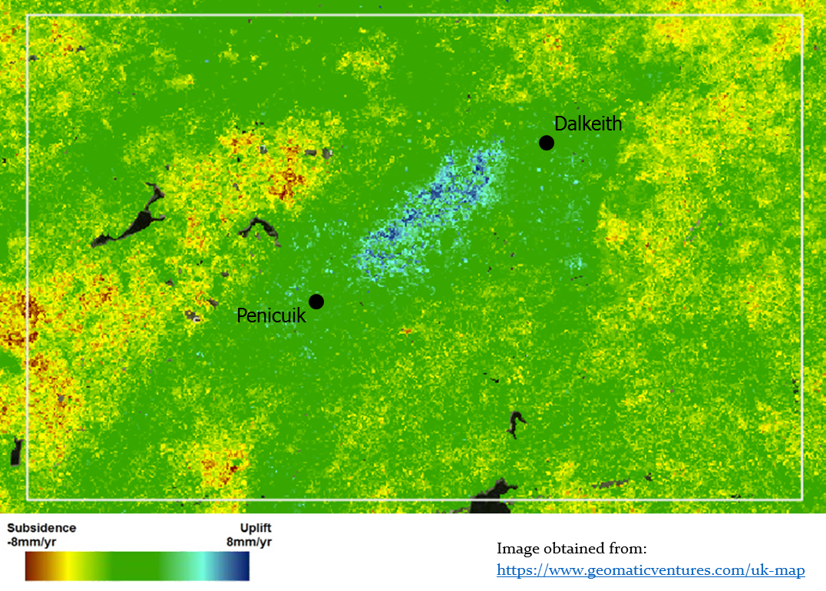

Figure .: Excerpt from 2017 relative land motion map

# Conceptual model

## Overview

Geological systems are inherently complex and simplification is necessary to fully understand the controlling mechanisms (Kruse and Younger 2009). Mining systems in particular have a number of site specific variables producing a unique hydraulic system for every mine. Hydrogeology will have a large impact in determining the heat flow processes in an abstraction/injection system and as such the hydrogeological conceptual model is the basis for the overall understanding of the system.

## Hydrogeological processes

The main hydrogeological components of a generic mining system are shown in Figure 4.1. This system comprises two levels of longwall mining overlain by pillar-and-stall workings and two shaft entries. Clearly this is a generalisation however, it highlights the main groundwater flow pathways in the system. The main inflows are similar to an unworked aquifer: recharge, regional groundwater flow and leakage from underlying confined aquifers. Mine specific elements are: water ingress through open workings (e.g. shafts, near-surface workings), leakage from formation into open mine workings and water make from adjacent connected mines. There is the added complexity that fluid flow is dependent on the groundwater rebound situation; turbulent flow becomes important when large open voids are refilling (Adams and Younger 2001). One simplification is to assume that the workings are fully saturated and the mine water has rebounded to natural levels.

Groundwater flow has a large impact on the heat movement and mines are complex systems which can be considered to have triple porosity: primary porosity of rock, mining voids and additional fractures caused by mining (Andrés, Ordóñez, and Álvarez 2017). This adds complexity to fluid flow and heat transfer modelling which requires a combination of matrix, fracture and open pipe flow (Ferket, Laenen, and Tongeren 2011). This complexity is shown in Figure 4.2 which focuses on the pillar-and-stall part of the conceptual model where the different matrix properties of the roof/floor strata and the coal pillars is shown.

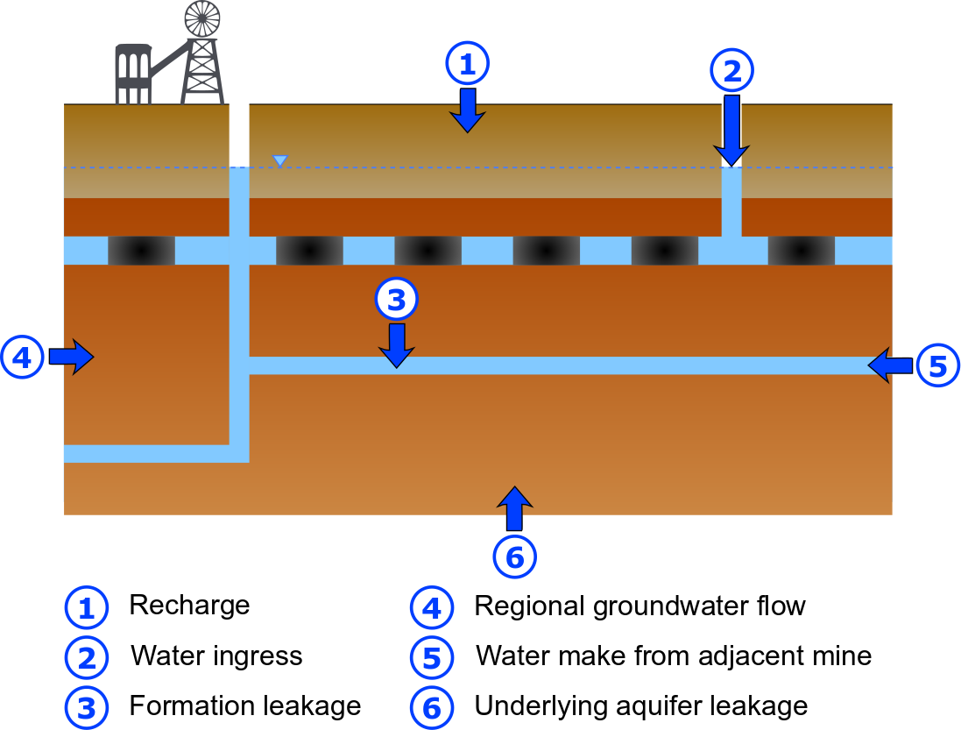

Figure .: Hydrogeological conceptual model for generic mine workings

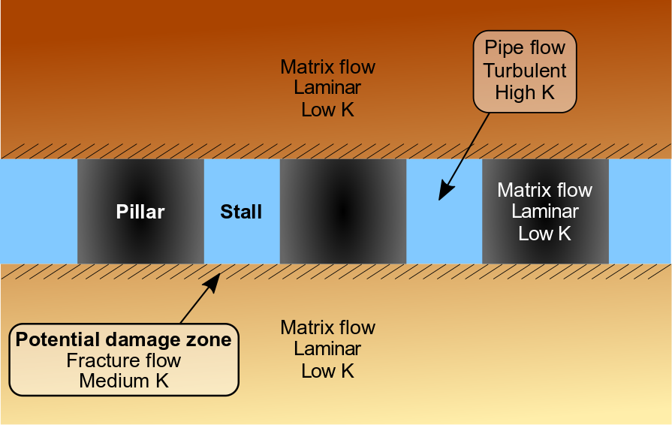

Figure .: Pillar and stall workings detail, adapted from Adams and Younger (2001)

## Heat flow

### Overview

Heat is transferred in a material through a number of different mechanisms: conduction, advection, convection and diffusion and it is important to define which mechanisms are dominant as they can influence the variability of different properties (Dethlefsen et al. 2016). A summary of the important mechanisms for mine workings is shown in Figure 4.3 and detailed in the sections below. Diffusion of heat is expected to be negligible compared to other processes and it has therefore been ignored at this stage.

### Conduction

Conduction is the heat flow through molecular interaction due to a temperature gradient. Conduction of heat from the surrounding rock, both the pillars and the surrounding strata, is important when considering the geothermal potential of mine workings (Ryan and Euler 2017) as the large water rock interface is a main contributor for replenishing the heat resource (Bailey et al. 2016). This is particularly the case when fluid velocity is small (Ghoreishi-Madiseh, Hassani, and Abbasy 2015), i.e. when the mine water is fully recovered and not being pumped.

The rate of conduction is governed by Fourier’s law, which is analogous to Darcy’s law and relates the heat flux and temperature:

The key components of the equation are the flow of heat (Q), thermal conductivity (λ) and the temperature (t). The thermal conductivity of the rock is a significant factor in determining how much heat is transferred from the matrix to the mine water (Ghoreishi Madiseh et al. 2012) and simulations have shown that conductive heat flow from the surrounding rock is 20 times greater than terrestrial heat flow (Malolepszy 2003). Geothermal heat flow should however not be ignored as it could be an important influence on mine water temperature (Raymond and Therrien 2008).

Conduction is not constrained to the matrix and water in man-made voids only; there is the potential for heat leakage between two closely spaces mine tunnels (Ghoreishi Madiseh et al. 2012). Therefore, any surrounding mine workings could have an impact on the thermal capacity of the mine and subsequently the sustainability of heat extraction. This is of particular importance in pillar-and-stall workings where several pockets of mine water are surrounded by a variety of void spaces.

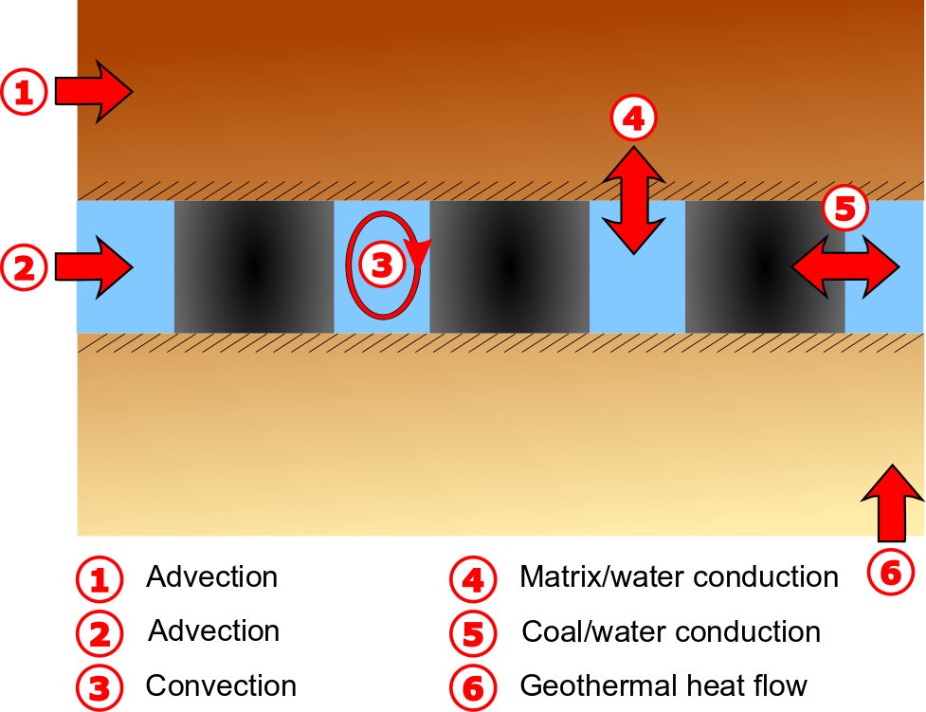

Figure .: Conceptualisation of heat flow mechanisms

### Advection

Heat will also be transferred by advection, which is the movement of heat based on the motion of a fluid. The fluid in this case is the regional groundwater flowing in the overlying and underlying strata and mine water flowing in the workings. Heat transport by this mechanism will be controlled by high permeability layers (Bridger and Allen 2014) predominantly the man-made voids such as adits and levels. The characteristics of water flow, and subsequently heat flow by advection, changes as the mine water table rises and it is therefore, assumed the mine workings in this model are fully saturated.

### Convection

Free convection is when the motion of the fluid is controlled by a density difference caused by temperature variations. All underground infrastructure, including mine workings, exist in the presence of a geothermal gradient (Love, Simmons, and Nield 2007) creating a density imbalance which drives convective heat transfer that could be important for extensive mine workings. Mine waters are known to have some stratification in their chemistry and small differences in salinity can also add to convective movement.

Convection by buoyancy forces, viscous friction and thermal diffusion in a vertical mine shaft has been modelled with results showing a thermal gradient does exist but is highly dependent on the aspect ratio of the shaft (i.e. radius/height). The mine shaft modelled was 1,200m deep compared to the height of the pillar-and-stall workings which are generally <5m. It is unlikely that changes in mine water properties in a room would be significant enough to drive a convection circuit. Convection has therefore, not been included in the conceptualisation at this stage.

## Assumptions

As stated above, a conceptual model is the simplification of reality which therefore means it has assumptions and justifications (Kruse and Younger 2009). The assumptions described in the sections above are summarised here for clarity:

* All materials are homogeneous and isotropic
* There is no regional groundwater gradient impacting the system
* Mine water levels have recovered and the system is fully saturated
* Heat diffusion and convection are considered negligible
* The damage zone above and below workings is ignored

This final assumption is significant as the damage zone could be important for both water and heat flow and it could impact on geo-mechanical properties. It has been excluded at this stage but should be considered further.

# Preliminary results

## Overview

An initial numerical model has been developed following the construction of the conceptual model. It is focussed on a simple 2D model of pillar workings which has allowed familiarisation with the modelling code. The model was initially set up for liquid flow and heat was coupled as a secondary step. Geo-mechanical processes have not yet been included.

## Model set up

### Geometry

Mine geometry is significant for fluid and heat flow pathways (Wolkersdorfer 2008) and the main impact on geometry is the extraction rate of the particular seam. Extraction rates for pillar-and-stall workings range from 48% to 60% compared to 90% extraction rate for longwall mining (Coal Authority pers. comms and (Paul L. Younger and Adams 1999). The extraction rate for pillar-and-stall workings could be higher where pillars were removed during retreat or in situations where is was more efficient to “rob” pillars than drive new roadways e.g. WW2.

The exact dimensions of the remaining pillars depends upon the specific resultant load following coal extraction. This varies significantly regionally and also with depth and thickness of coal seam; and reality is unlikely to correspond to mine plans.

Standard values from the Carboniferous coal measures of the UK indicate that rooms were generally 6 to 9m wide and pillars 9 to 30m wide (Paul L. Younger and Adams 1999). This corresponds to graphs provided in design guidance for mine workings (NCB 1972) which indicates that below ~366m depth pillars should be 9m wide (1,200ft depth and 30ft wide).

This study has used a pillar width of 10m which is at the lower end of the scale representing a worst case scenario for pillar impact. The height of the pillar is dependent on the particular coal seam thickness an average value of 1.3m is taken from graphs comparing pillar width, overburden cover depth and road height (NCB 1972).

Subsequently, the stall (room) width is taken to be 6m which is also at the lower end of estimates. This however, corresponds to an extraction rate of ~38% which is at the lower end of estimates and future iterations of the model will consider a larger stall width to correspond to a worst case scenario.

The thickness of overburden was decreased from 300m in the initial model to 50m to reduce calculation time. Pressure boundaries were applied to the top and bottom to simulate the workings at 300m depth. Details of the model geometry are provided in Figure 5.1.

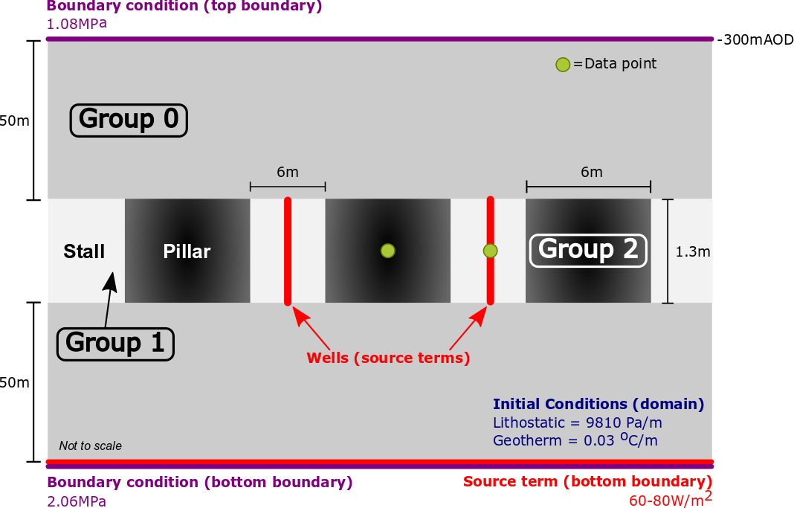

Figure .: Numerical model set up

### Processes

The processes included in this initial model are liquid flow and heat transport; geo-mechanical processes will be included at a later stage. Liquid flow was chosen as it’s an incompressible fluid and groundwater flow is not suitable for this scenario (see section 4.2). The processes were initially modelled separately to resolve calculation issues prior to coupling the processes together.

### Source terms

The object of the modelling is to determine how the pillars respond to cyclical stresses of heat and water flow and therefore a source term in extracting water from the stalls is required. Initially one “well” was included but this created an artificially high drawdown due to the 2D nature of the model. In reality the stalls would be connected to each other in 3D beyond the extent of the pillars but in the model they are effectively separated by the coal pillar. To counteract this an additional well was included in the adjacent room and it was given the same parameters as the initial well. A sensitivity analysis was undertaken on the impact on head values by extraction rate, details in section 5.3 below.

A source term representing geothermal heat flux will be applied to the bottom boundary in future stages of modelling. Estimates for coal mining areas of the UK indicate it ranges between ~60 to 80 W/m2 (D Banks 2008).

### Boundary conditions

The pressure boundary conditions shown in Figure 5.1 are based on the following calculation and assuming the water table (h) is 100m above the top of the model:

### Initial conditions

The initial pressure conditions throughout the domain represents the hydrostatic pressure. For the purposes of modelling a water table 100m above the top of the model is assumed i.e. the workings are fully saturated.

A thermal gradient is given to the domain to represent the geothermal gradient. There are few heat flow measurements for Scotland but estimates of the geothermal gradient under Glasgow suggest it to be 30.2°C/km (BGS 2017) this is similar to the estimate of the UK coal measures of 30.7°C/km (Bailey et al. 2016).

### Fluid properties

The fluid is set as water with the properties given in Table 5.1.

Table .: Model fluid parameters

|  |  |  |  |  |
| --- | --- | --- | --- | --- |
| **Fluid** | **Density** | **Viscosity** | **Specific capacity** | **Thermal conductivity** |
| ρ | μ | *c* | λ |
| kg m-3 | Pa s | J kg-1 K-1 | W m-1 K-1 |
| Liquid | 1000 | 0.001 | 4184 | 0.6 |

### Material properties

The material properties used in this model are shown in Table 5.2 alongside the data source. At this stage several parameters (thermal expansion, heat dispersion, tortuosity and storage) were left as default values, these will be examined in later stages.

The values for heat capacity provided in (Blomberg et al. 2017) are the volumetric heat capacity values (J m-3 K-1) however as OGS uses specific capacity (J kg-1 K-1) the following conversion calculation was used:

Table .: Model material properties

|  |  |  |  |  |  |  |
| --- | --- | --- | --- | --- | --- | --- |
| **Material** | | **Density** | **Specific capacity** | **Thermal conductivity** | **Porosity** | **Permeability** |
| ρ | *c* | λ | η | k |
| kg m-3 | J kg-1 K-1 | W m-1 K-1 | - | m2 |
| Group 0 | Coal Measures | 2600E | 909E | 4DF | 0.15A | 1.2x10-13 A |
| Group 1 | Mine water | 1000 | 4184E | 0.6D | 1 | 1 |
| Group 2 | Coal (pillar) | 2600E | 692E | 0.3DF | 0.02B | 1x10-14 BC |

A: Scotland’s aquifers and groundwater bodies (BGS 2015)

B: Coal resources in the Yorkshire-Nottinghamshire coalfield (Holloway et al. 2002)

C: Permeability of coalbed reservoirs (Levine 1996)

D: Earth Energy Designer (Blomberg et al. 2017)

E: Geothermal reservoirs in abandoned workings (Malolepszy 2003)

F: Study into potential for deep geothermal energy in Scotland (Gillespie M.R., Crane E.J. 2013b)

## Initial results

### Overview

Once initial model issues were corrected, preliminary work has been undertaken to determine how certain properties influence the model and how important they are to the results. Two reference points were taken in the model to compare the head changes influenced by changes. These are shown as “data points” in Figure 5.1 with one in a stall and one in a pillar to understand changes between the two materials. Model outputs are included in Appendix A.

### Water permeability

One complication in the model is that the stall areas, which are essentially water filled voids, have to be modelled as a material group (Group 1). Initially it was given the properties of water (Table 5.2) and a permeability = 1. This caused calculation problems in the model, due to the large range compared to other material groups which were 13 – 14 orders of magnitude smaller. Analysis was undertaken to determine at what point the value of permeability becomes impacts the results, this is shown in Figure 5.2. As expected changing the permeability of the stall doesn’t impact the total head experienced in the coal pillar but does have a bearing on the stall. Above around 1 x 10-6 m2 the model does not give sensible results. As the permeability is reduced closer to the value for the coal (1 x 10-14 m2) it begins to impact the head values as seen in Figure 5.2. The model outputs of selected values are given in Appendix A. The value chosen for future modelling will therefore be 1 x 10-9m2 which is permeable enough for it to not cause an impact, but not too permeable to impact the model results.



Figure .: Stall permeability sensitivity analysis

### Abstraction rate

The abstraction rate is the sole source term in the model at this stage, and is expected to have an impact on the head values. The initial rate of 1 x 10-5m3/s was altered incrementally with resultant modelled head values in both the pillar and stall shown in Figure 5.3.

As expected this shows that there is a linear relationship between abstraction and head values and that there is more drawdown in the stall compared to the pillar. Model outputs are shown in Appendix A. A review of temperature data showed a negligible influence from abstraction.



Figure .: Abstraction rate sensitivity analysis

### Pressure boundaries

Boundaries are important in any model and the impact the top boundary has on the head in the mine has been modelled to see how much it effects the results. This was tested by increasing the top boundary pressure value which is equivalent to increasing the hydrostatic pressure and therefore the height of water above the mine. The linear increase is shown in Figure 5.4 and is the expected response.



Figure .: Pressure boundary sensitivity analysis

### Sensitivity analysis comparison

A simple comparison has been undertaken on the effects of changing these three parameters has on modelled head values. The percentage change in parameter is shown in Figure 5.5 against the associated change in head value for each different parameter. The results shown are for stall data but a similar pattern is seen for the stall monitoring point.

The stall permeability value has least impact which corresponds to the conclusion that between threshold limits the value chosen is not important for head values. The results show that for this model set up the pressure change has a large impact on the head values than abstraction rate.



Figure .: Comparison of sensitivity analyses

## Model development

The next stage is to undertake further analysis on parameters of this 2D model to identify which parameters has the largest effect on the model. The model will then be developed to include transient conditions.

Another model development will be to develop a 3D model, which will allow an understanding of how important mine geometry is for this model.

# Plan

A timetable has been developed to take into account key milestones and to provide a framework to ensure the project is completed within the funding timeframe. Figure 6.1 shows a detailed plan for the next six months and the overarching milestone for this period is to have data to present at the London Geothermal symposium which is expected to take place in November. It is anticipated that by then the conceptual and initial numerical modelling will be complete (question 1) and that the case study model (question 2) will be in progress.



Figure .: Detailed 6 month plan

An outline plan for the remainder of the PhD is shown in Figure 6.2 with high level estimates on the timings of completion of the different questions. Selected relevant conferences, as outlined in Table 6.1 have also been shown. In addition to those detailed it is expected that there will be a conference organised by the International Mine Waters Association (IMWA) in 2019. Time at Quintessa (CASE sponsor) has been included during the expected model verification stage to make use of modelling expertise and computer capability.



Figure .: Outline PhD plan

Table .: Relevant conferences

|  |  |  |  |
| --- | --- | --- | --- |
| **Conference** | **Date** | **Organiser** | **Location** |
| PGR 2018 | May 2018 | University of Edinburgh | Edinburgh |
| All Energy 2018 | May 2018 | Scottish Renewables | Glasgow |
| International sustainable energy | Oct 2018 | European Geothermal Energy Council | Austria |
| UK Geothermal symposium | Nov 2018 | Geological Society/BritGeothermal | London |
| Bryan Lovell Meeting 2019* | Jan 2019 | Geological Society | London |
| GeoTHERM 2019 | Feb 2019 | European Geothermal Energy Council | Germany |
| EGU 2019 | April 2019 | European Geosciences Union | Austria |
| PGR 2019 | May 2019 | University of Edinburgh | Edinburgh |
| All Energy 2019 | May 2019 | Scottish Renewables | Glasgow |
| EGU 2020 | April 2020 | European Geosciences Union | Austria |
| World Geothermal congress | May 2020 | International Geothermal Association | Iceland |

*Title: Role of geological science in the decarbonisation of power production, heat, transport and industry

# Resources

## Budget

The project has a £5,000 (£1,150 per year) research training support grant (RTSG) and additional funding from CASE sponsor Quintessa Ltd. A high level estimate of defined and expected costs is shown in Table 7.1. These are subject to change, particularly as different conferences are identified or the actual costs of data processing are established.

Table .: Budget

|  |  |  |
| --- | --- | --- |
| **Income** |  |  |
| RTSG | £5,000 | NERC research training support grant |
| CASE sponsorship | £5,000 | Quintessa Ltd |
| **Total** | **£10,000** |  |
| **Expenditure** |  |  |
| Software license | £540 | TecPlot |
| Conferences attended | £320 | PGR, Geothermal symposium, Mining the future |
| Laptop | ~ £1,200 | Estimate for laptop to develop numerical models |
| Data processing | ~£3,000 | Estimate for external InSAR data processing |
| Conferences | ~£3,000 | Estimated |
| **Total** | **~£8,060** |  |

## Data management plan

Effective data management is essential for a successful project. There are various locations for data storage in the University and GeoScience school systems with different backup and storage size capabilities. An outline of my data storage plan is shown in Table 7.2. Alongside this I employ a personal documentation back up system. This includes saving critical documents to a USB stick daily and transferring to an external hard drive weekly.

Table .: Data storage

|  |  |  |
| --- | --- | --- |
| File path | Information | Detail |
| C:\Workspace | Desktop local scratch space | Software saved & models run from here |
| C:\Users | Desktop local space | Only used if not at own computer |
| M:\ | Personal drive/scratch space | General documents and admin files |
| Z:\Datastore | Research data store 500Gb | Modelling outputs and crucial documents |

## Training

Anticipated training needs are shown in Table 7.3 alongside identified courses and available resources. In addition to this I have undertaken a professional internship placement at TownRock Energy to develop my professional skills and for an industry perspective on mine water heat schemes.

Table .: Training requirements

|  |  |
| --- | --- |
| **Skills / training required** | **Courses / resources identified** |
| Coupled groundwater modelling | Hydrogeology 2 course (self-directed learning) |
| Python | NMDM course (E3 DTP training)  Codecademy (self-directed online course)  Geochemistry & data analysis course (self-directed learning) |
| Rock mechanics and mechanical failure mechanisms | Journals/books (self-directed reading)  Undergrad course notes (self-directed learning) |
| Geostatistics | BGS geostatistics course (E3 DTP training)  BIOSS training course (E3 DTP training) |
| Hydrodynamics | Journals/books (self-directed reading) |

# Supervisory arrangements

|  |  |  |
| --- | --- | --- |
| Principal supervisor: | Chris McDermott (70%) | University of Edinburgh |
|  |  |  |
| Co-supervisors: | Andrew Fraser Harris (15%) | University of Edinburgh |
|  | Stuart Gilfillan (15%) | University of Edinburgh |
|  |  |  |
| External: | Hugh Barron | BGS |
|  | Alex Bond | Quintessa (CASE support) |
|  |  |  |
| Advisor: | Stuart Haszeldine | University of Edinburgh |

# Collaborations

There are several different universities and organisations with interest in mine water heat projects and initial research has identified several groups with collaboration potential shown in Figure 9.1. Two UK based exploratory projects are currently underway: the BGS GeoObservatory site in Glasgow (GGERFS) and a demonstrator project being investigated in Bridgend, Wales.

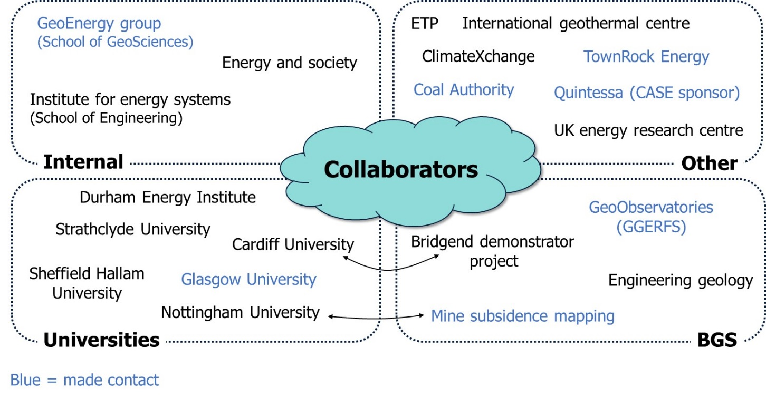

Figure .: Potential collaborators

# References

Adams, R., and P L Younger. 2001. “A Strategy For Modeling Ground Water Rebound in Abandoned Deep Mine Systems.”

Allen, K. G., T. W. Von Backström, D. G. Kröger, and A. F.M. Kisters. 2014. “Rock Bed Storage for Solar Thermal Power Plants: Rock Characteristics, Suitability, and Availability.” *Solar Energy Materials and Solar Cells* 126: 170–83.

Andrés, C., A. Ordóñez, and R. Álvarez. 2017. “Hydraulic and Thermal Modelling of an Underground Mining Reservoir.” *Mine Water and the Environment* 36(1): 24–33. http://link.springer.com/10.1007/s10230-015-0365-1.

Bagde, Manoj N., and Vladimir Petroš. 2009. “Fatigue and Dynamic Energy Behaviour of Rock Subjected to Cyclical Loading.” *International Journal of Rock Mechanics and Mining Sciences* 46(1): 200–209.

Bailey, M. T. et al. 2016. “Heat Recovery Potential of Mine Water Treatment Systems in Great Britain.” *International Journal of Coal Geology* 164: 77–84. http://dx.doi.org/10.1016/j.coal.2016.03.007.

Banks, D. 2008. *An Introduction to Thermogeology: GroundSource Heating and Cooling*. Blackwell Pub.

Banks, D., A. Fraga Pumar, and I. Watson. 2009. “The Operational Performance of Scottish Minewater-Based Ground Source Heat Pump Systems.” *Quarterly Journal of Engineering Geology and Hydrogeology* 42(3): 347–57. http://qjegh.lyellcollection.org/cgi/doi/10.1144/1470-9236/08-081.

Banks, David. 2017. *Integration of Cooling into Mine Water Heat Pump Systems F1.1*.

Banks, David, Helge Skarphagen, Robin Wiltshire, and Chris Jessop. 2003. “Mine Water as a Resource: Space Heating and Cooling via Use of Heat Pumps.” *Land Contamination & Reclamation* 11(2): 191–98. http://openurl.ingenta.com/content/xref?genre=article&issn=0967-0513&volume=11&issue=2&spage=191.

Bateson, Luke, Francesca Cigna, David Boon, and Andrew Sowter. 2015. “The Application of the Intermittent SBAS (ISBAS) InSAR Method to the South Wales Coalfield, UK.” *International Journal of Applied Earth Observation and Geoinformation* 34(1): 249–57. http://dx.doi.org/10.1016/j.jag.2014.08.018.

BEIS. 2017. “UK Energy Statistics: Statistical Press Release June 2017.” https://www.gov.uk/government/news/uk-energy-statistics-statistical-press-release-june-2017 (November 14, 2017).

Beveridge, R, S Brown, Gallagher MJ, and Merrit JW. 1991. “Economic Geology.” In *Geology of Scotland*, ed. GY Craig. , 545–95.

BGS. 2015. “Scotland’s Aquifers and Groundwater Bodies.” *Groundwater Science Programmes* (OR/15/028).

———. 2017. “UKGEOS - Glasgow Geothermal Energy Research Field Site ( GGERFS ): Initial Summary of the Geological Platform.” : 201.

Blomberg, Thomas et al. 2017. “Earth Energy Designer.”

Bridger, D. W., and D. M. Allen. 2014. “Influence of Geologic Layering on Heat Transport and Storage in an Aquifer Thermal Energy Storage System.” *Hydrogeology Journal* 22(1): 233–50.

DECC. 2011. “UK Renewable Energy Roadmap.” *Carbon* 5(July): 293–98. http://www.decc.gov.uk/en/content/cms/meeting_energy/renewable_ener/re_roadmap/re_roadmap.aspx.

Dethlefsen, Frank, Christof Beyer, Volker Feeser, and Ralf Köber. 2016. “Parameterizability of Processes in Subsurface Energy and Mass Storage: Supported by a Review of Processes, Codes, Parameters, and a Regional Example: Schleswig-Holstein, Germany.” *Environmental Earth Sciences* 75(10).

Elliott, David. 2016. “A Balancing Act for Renewables.” *Nature Energy* 1(1): 1–3. http://dx.doi.org/10.1038/nenergy.2015.3.

Ferket, Helga L W, Ben J M Laenen, and Peter C H Van Tongeren. 2011. “Transforming Flooded Coal Mines to Large-Scale Geothermal and Heat Storage Reservoirs : What Can We Expect ?” *IMWA. Mine Water - Managing the Challenges*: 171–76.

Gee, David et al. 2017. “Ground Motion in Areas of Abandoned Mining: Application of the Intermittent SBAS (ISBAS) to the Northumberland and Durham Coalfield, UK.” *Geosciences* 7(3): 85. http://www.mdpi.com/2076-3263/7/3/85.

Ghoreishi-Madiseh, S. A., F. Hassani, and F. Abbasy. 2015. “Numerical and Experimental Study of Geothermal Heat Extraction from Backfilled Mine Stopes.” *Applied Thermal Engineering* 90: 1119–30. http://dx.doi.org/10.1016/j.applthermaleng.2014.11.023.

Ghoreishi Madiseh, S. A., Mory M. Ghomshei, F. P. Hassani, and F. Abbasy. 2012. “Sustainable Heat Extraction from Abandoned Mine Tunnels: A Numerical Model.” *Journal of Renewable and Sustainable Energy* 4(3).

Gillespie M.R., Crane E.J., Barron H.F. 2013a. 2 British Geological Survey *Study into the Potential for Deep Geothermal Energy in Scotland. Volume 2 of 2*.

———. 2013b. “Study into the Potential for Deep Geothermal Energy in Scotland. Volume 2 of 2.” *British Geological Survey* 2(August): 125.

Hall, Andrew, John Ashley Scott, and Helen Shang. 2011. “Geothermal Energy Recovery from Underground Mines.” *Renewable and Sustainable Energy Reviews* 15(2): 916–24. http://www.sciencedirect.com.ezproxy.is.ed.ac.uk/science/article/pii/S136403211000376X (September 26, 2017).

Hamm, Virginie, and Behrooz Bazargan Sabet. 2010. “Modelling of Fluid Flow and Heat Transfer to Assess the Geothermal Potential of a Flooded Coal Mine in Lorraine, France.” *Geothermics* 39(2): 177–86. http://dx.doi.org/10.1016/j.geothermics.2010.03.004.

Holloway, S, N Jones, Creedy D, and Garner K. 2002. “Can New Technologies Be Used To Exploit the Coal.” : 1–23.

Jaiswal, Ashok, and B. K. Shrivastva. 2009. “Numerical Simulation of Coal Pillar Strength.” *International Journal of Rock Mechanics and Mining Sciences* 46(4): 779–88.

Jessop, Alan. 1995. “Geothermal Energy From Old Mines At Springhill , Nova Scotia , Canada.” *Proceedings* 17(April 1993): 463–68. http://www.geothermal-energy.org/pdf/IGAstandard/WGC/1995/1-jessop.pdf.

Kolditz, O. et al. 2012. “OpenGeoSys: An Open-Source Initiative for Numerical Simulation of Thermo-Hydro-Mechanical/chemical (THM/C) Processes in Porous Media.” *Environmental Earth Sciences* 67(2): 589–99.

Kruse, N. A., and P. L. Younger. 2009. “Development of Thermodynamically-Based Models for Simulation of Hydrogeochemical Processes Coupled to Channel Flow Processes in Abandoned Underground Mines.” *Applied Geochemistry* 24(7): 1301–11. http://dx.doi.org/10.1016/j.apgeochem.2009.04.003.

Levine, Jeffrey R. 1996. “Model Study of the Influence of Matrix Shrinkage on Absolute Permeability of Coal Bed Reservoirs.” *Geological Society, London, Special Publications* 109(1): 197–212. http://sp.lyellcollection.org/lookup/doi/10.1144/GSL.SP.1996.109.01.14.

Loredo, C., N. Roqueñí, and A. Ordóñez. 2016. “Modelling Flow and Heat Transfer in Flooded Mines for Geothermal Energy Use: A Review.” *International Journal of Coal Geology* 164: 115–22. http://dx.doi.org/10.1016/j.coal.2016.04.013.

Love, Andrew J., Craig T. Simmons, and D. A. Nield. 2007. “Double-Diffusive Convection in Groundwater Wells.” *Water Resources Research* 43(8).

Malolepszy, Zbigniew. 2003. “Low Temperature, Man-Made Geothermal Reservoirs in Abandoned Workings of Underground Mines.” *Twenty-Eighth Workshop on Geothermal Reservoir Engineering*: 27–29.

National Records of Scotland. 2017. “Statistics and Data.” https://www.nrscotland.gov.uk/ (November 14, 2017).

NCB. 1972. *Design of Mine Layouts: With Reference to Geological and Geometrical Factors*. ed. Working party Report.

Peralta Ramos, Esmeralda, Katrin Breede, and Gioia Falcone. 2015. “Geothermal Heat Recovery from Abandoned Mines: A Systematic Review of Projects Implemented Worldwide and a Methodology for Screening New Projects.” *Environmental Earth Sciences* 73(11): 6783–95. http://dx.doi.org/10.1007/s12665-015-4285-y.

Pfenninger, Stefan, and James Keirstead. 2015. “Renewables, Nuclear, or Fossil Fuels? Scenarios for Great Britain’s Power System Considering Costs, Emissions and Energy Security.” *Applied Energy* 152: 83–93. http://dx.doi.org/10.1016/j.apenergy.2015.04.102.

Raymond, Jasmin, and René Therrien. 2008. “Low-Temperature Geothermal Potential of the Flooded Gaspé Mines, Québec, Canada.” *Geothermics* 37(2): 189–210.

Renz, A., Wolfram Rühaak, P. Schätzl, and H. J.G. Diersch. 2009. “Numerical Modeling of Geothermal Use of Mine Water: Challenges and Examples.” *Mine Water and the Environment* 28(1): 2–14.

Rodríguez, Rafael, and María B. Díaz. 2009. “Analysis of the Utilization of Mine Galleries as Geothermal Heat Exchangers by Means a Semi-Empirical Prediction Method.” *Renewable Energy* 34(7): 1716–25.

Ryan, Anderson, and De Souza Euler. 2017. “Heat Stress Management in Underground Mines.” *International Journal of Mining Science and Technology* 27(4): 651–55. http://dx.doi.org/10.1016/j.ijmst.2017.05.020.

Sizer, K E, and M Gill. 2000. “Pillar Failure in Shallow Coal Mines — a Recent Case History.” (December).

Sowter, Andrew et al. 2017. “Supporting Energy Regulation by Monitoring Land Motion on a Regional and National Scale: A Case Study of Scotland.” *Proceedings of the Institution of Mechanical Engineers, Part A: Journal of Power and Energy* 232(1): 95765091773722. http://journals.sagepub.com/doi/10.1177/0957650917737225.

Verhoeven, René. 2017. “6th London Geothermal Symposium.”

Watzlaf, George R., and Terry E. Ackman. 2006. “Underground Mine Water for Heating and Cooling Using Geothermal Heat Pump Systems.” *Mine Water and the Environment* 25(1): 1–14.

Wolkersdorfer, Christian. 2008. Water Management at Abandoned Flooded Underground Mines: Fundamentals, Tracer Tests, Modelling, Water Treatment *Water Management at Abandoned Flooded Underground Mines: Fundamentals, Tracer Tests, Modelling, Water Treatment*.

Younger, P. L. 2001. “Mine Water Pollution in Scotland: Nature, Extent and Preventative Strategies.” *Science of the Total Environment* 265(1–3): 309–26.

Younger, Paul L., and R. Adams. 1999. *Predicting Mine Water Rebound Research and Development*.

Appendix : Initial model results

Modelling effect of permeability in stall (Group 1). Abstraction in all cases = 1x10-5m3/s

Note: Permeability of coal (Group 2) = 1 x10-14 m2

|  |  |  |
| --- | --- | --- |
|  |  |  |
|  |  |  |
| Stall permeability = 1 x10-14 m2 | Stall permeability = 1 x10-11 m2 | Stall permeability = 1 x10-5 m2  (numerically unstable) |

Modelling effect of water abstraction from stalls (source term). Stall permeability in all cases = 1x10-10m2

|  |  |  |
| --- | --- | --- |
|  |  |  |
|  |  |  |
| Abstraction = 1 x10-6 m3/s | Abstraction = 1 x10-5 m3/s | Abstraction = 8 x10-5 m3/s |